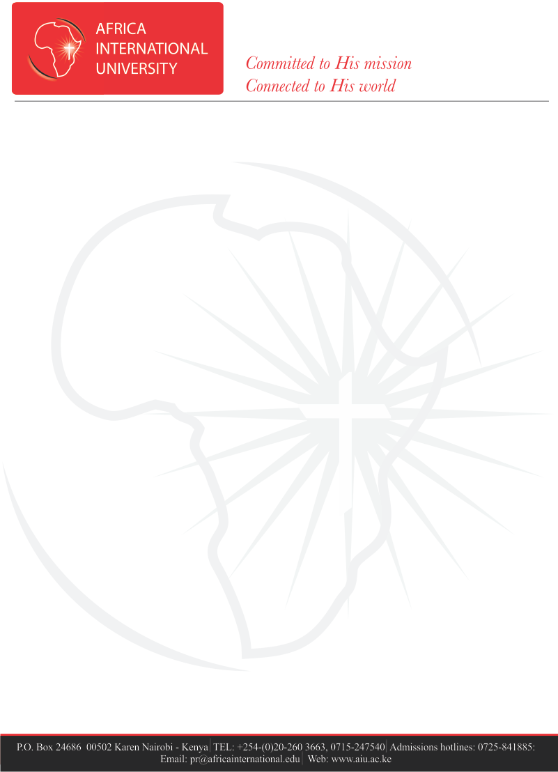

**ADDITIONAL INFORMATION FOR NEW STUDENTS:**

1. **YOU are required to come with at least 8 A4 size writing pads/books of at least 100 pages, and enough pens.**
2. **YOU are required to apply for HELB loan to cover part of your Tuition fees and other university expenses including Hostel, Insurance, Food and Books.**
3. **YOU are required to have a medical insurance cover from any of the following options:**
   1. **The University Medical Fee at KES. 3,500 per semester. Proof of full year payment for National Hospital Insurance Fund (NHIF) is encouraged for those who choose this option in case of hospitalization or for services that can be waived under NHIF.**
   2. **Proof of adequate Medical Insurance cover from a recognized/reputable Insurance Company. Ensure that they cover hospitals within Karen-Kikuyu Region in case of emergency situations.**
4. **You are required to undergo a full medical examination. The medical from is part of the attachments sent to your email.**
5. **We have limited housing and allocations will be done on the reporting date (Tuesday 27th August 2024) on first come first served basis.** 
   1. **The hostels have shared rooms and each student will pay a total of KES. 16,000 per semester (KES.4,000 per month).**
   2. **Beds and mattresses will be provided hence students will be required to carry their beddings and other personal effects.**
6. **Students are expected to buy their own food and refreshments from the university cafeteria hence the need to budget for meals based on their choice as follows:**

|  |  |
| --- | --- |
| **MEAL** | **PRICE RANGE (KShs) per day** |
| **Breakfast** | **40 - 120** |
| **Lunch/ Supper** | **70 - 240** |

**There is also the option of students cooking for themselves in the shared hostels. Incase one will prefer to cook, there is need to carry basic cooking utensils and only Gas cooking Meko is allowed.**

1. **The Karen weather is often cold, please carry some warm clothes and bedding.**
2. **YOU are required to abide by all the university regulations governing the conduct and discipline of students as stipulated in the Student Handbook.**
3. **YOU can visit** [Fee Structure – Africa International University (aiu.ac.ke)](https://www.aiu.ac.ke/fee-structure/) **for more details on the fee structure including the bank details.**